**Lab Exercise 10**

**Creating and Executing a Basic GitHub Actions Workflow**

Step 1: Create a new GitHub repository

1.1Open the browser in your lab, go to github.com, and log in to your account

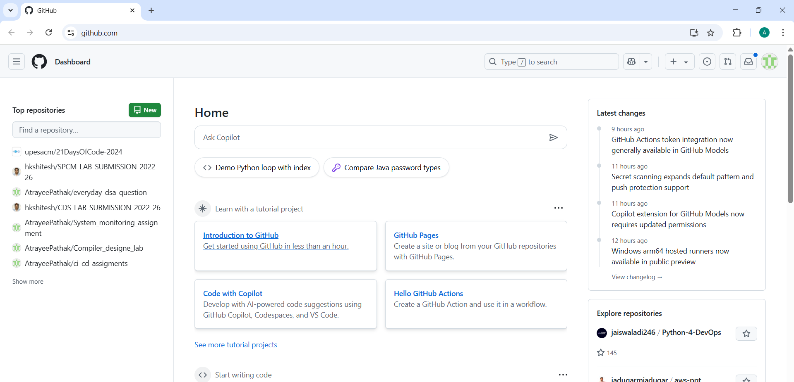

1.2 Click on the + icon from the upper-right corner of the page and select New repository from the drop-down menu

1.3 Enter the name and description for the GitHub repository

1.4 Choose Public for the repository type

1.5 Select Initialize this repository with a README to include a README file for the repository

1.6 Click on the Create repository button

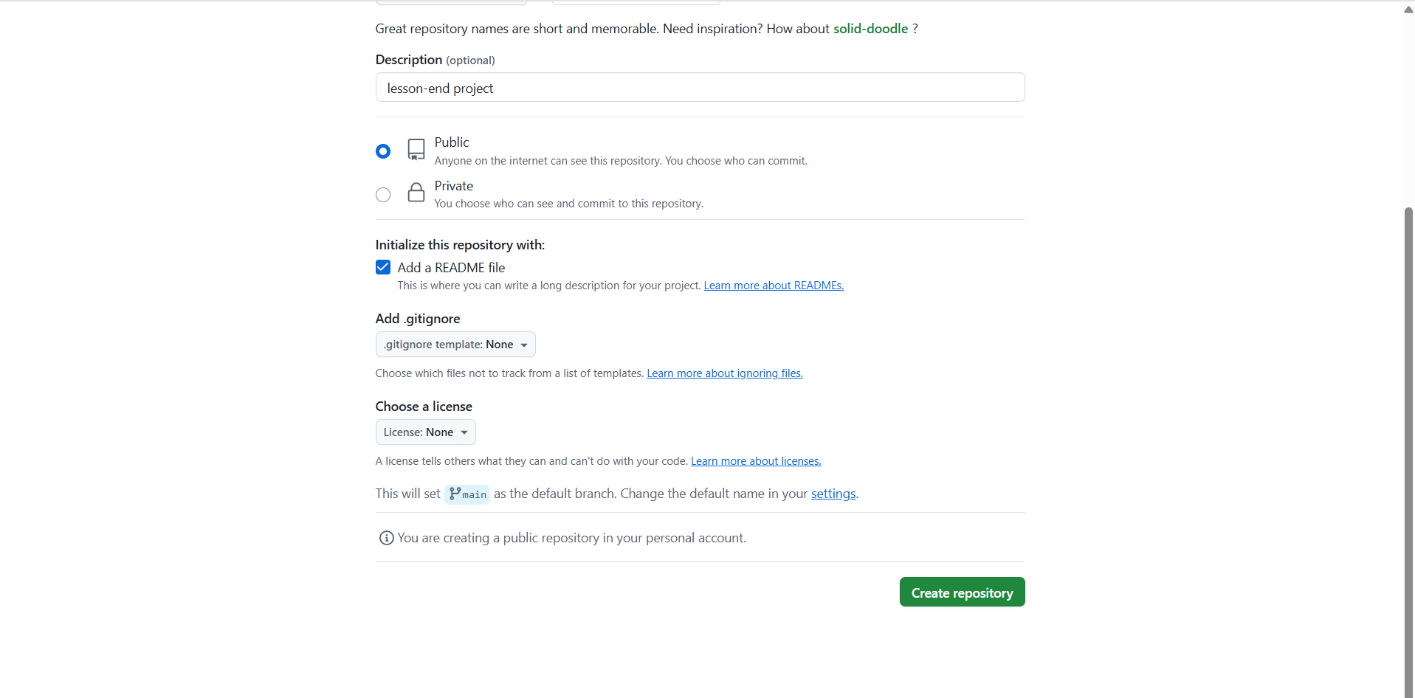

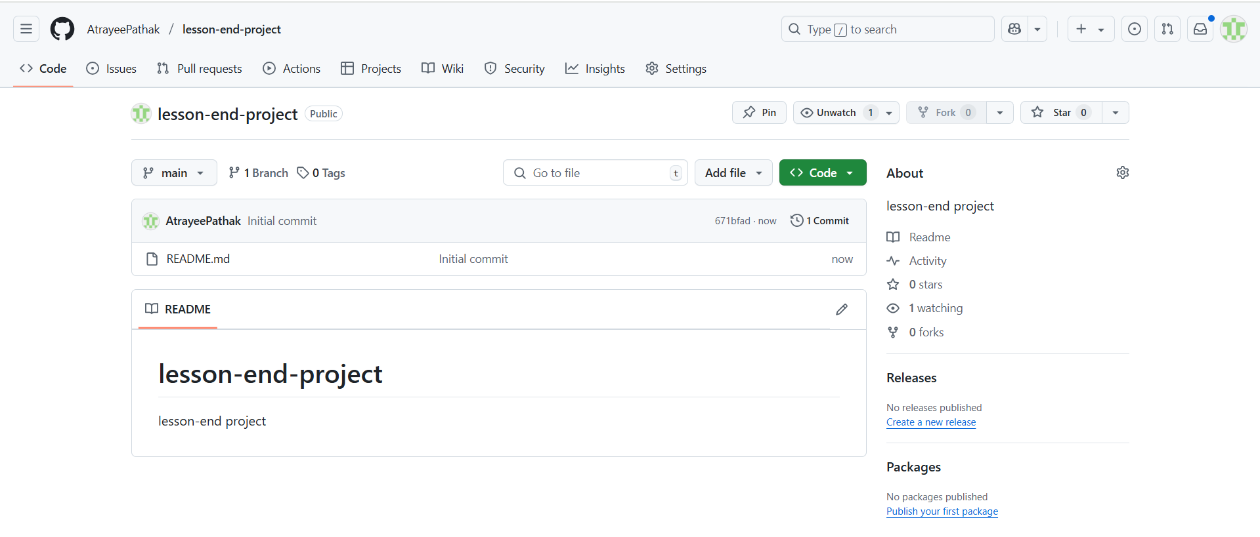

Step 2: Create and execute a new workflow file

2.1 Navigate to the Actions tab and click on set up a workflow yourself to create a .github/workflows directory

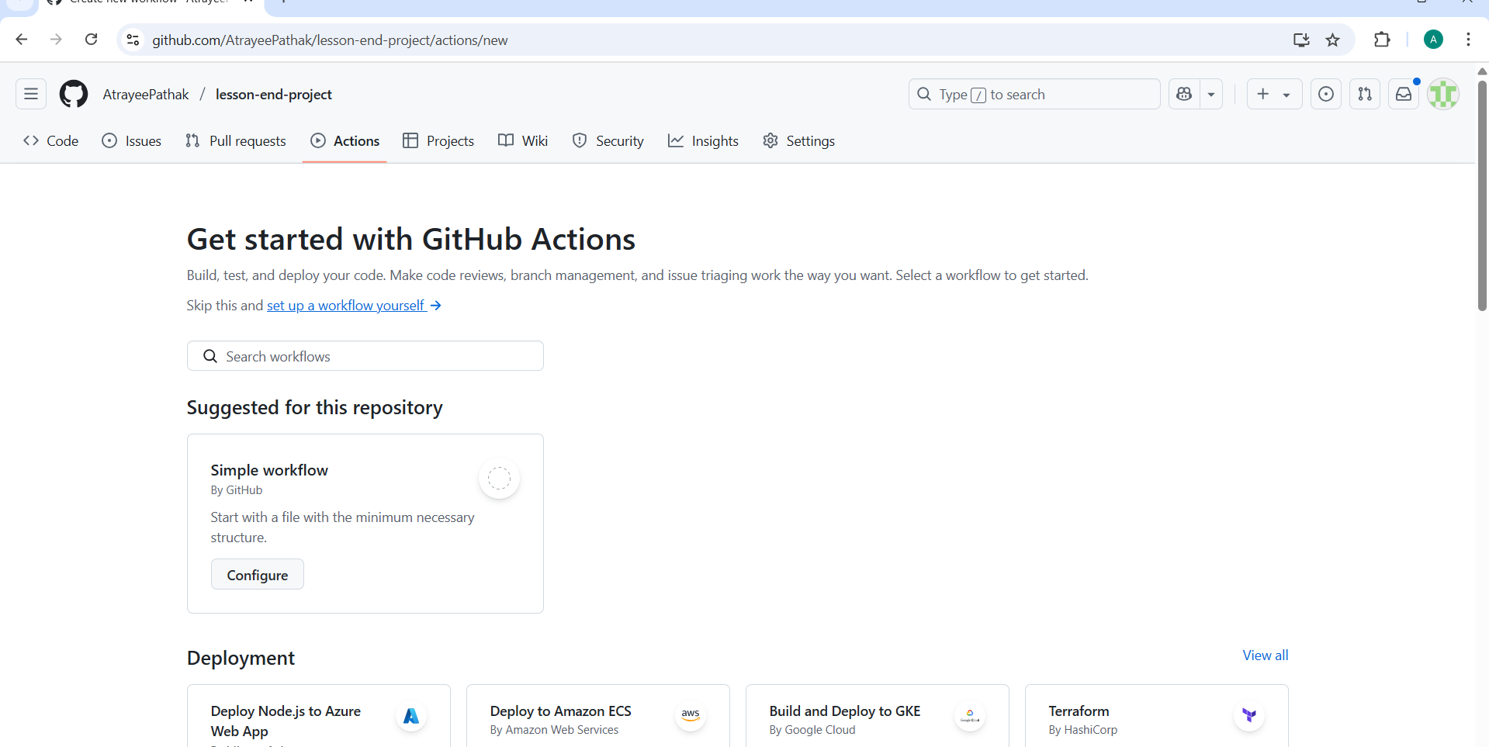

2.2 Create a new workflow file basic-workflow.yml with the below code, then click on Commit changes:

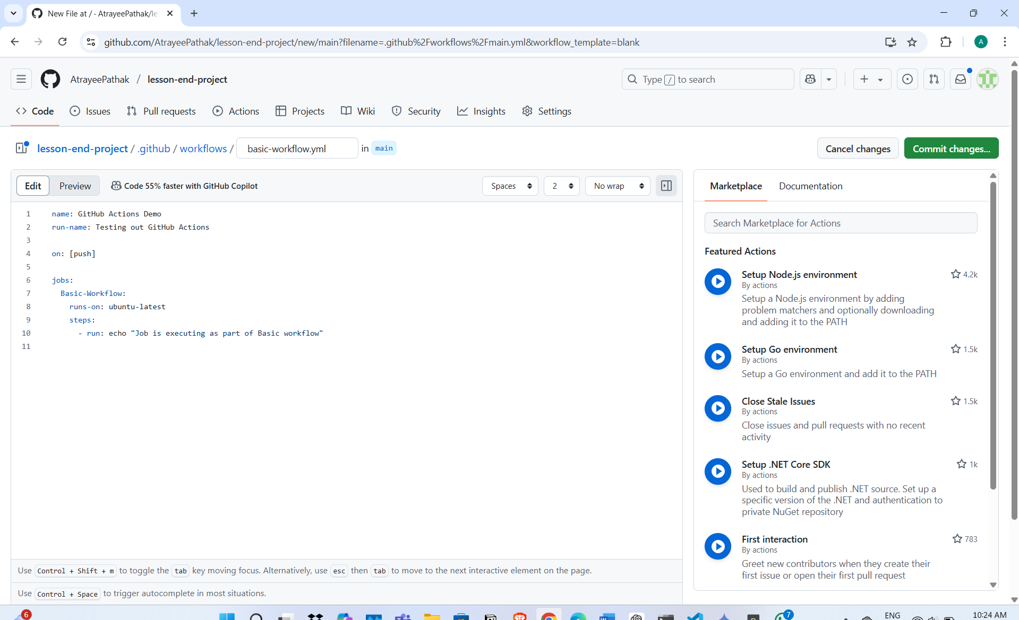

2.3 Add the Commit message as Create basic-workflow.yml and then click on Commit changes to save the workflow file in the code repository

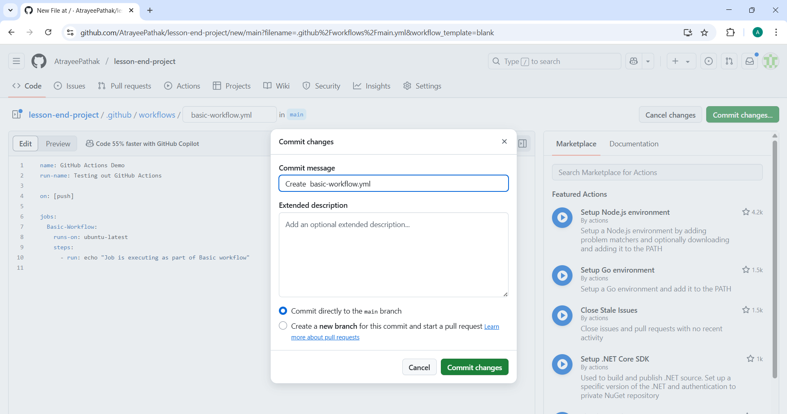

2.4 Navigate to the Actions tab to access the workflow execution, and under All workflows, click on the Testing out GitHub Actions

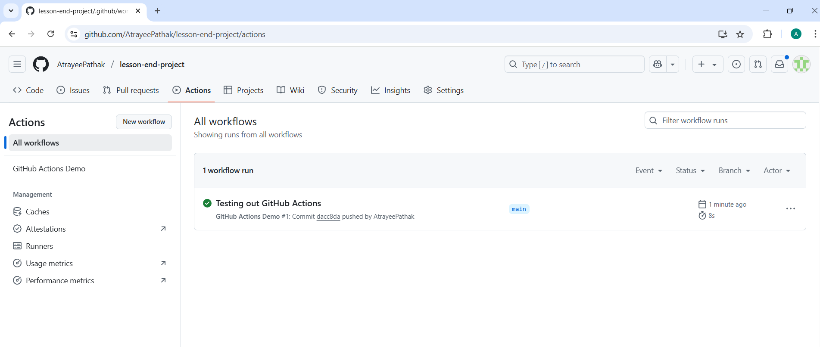

The Basic-Workflow screen will appear as shown below:

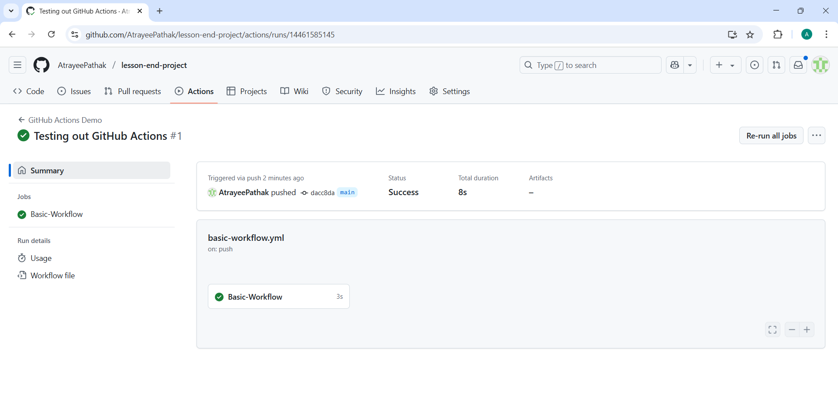

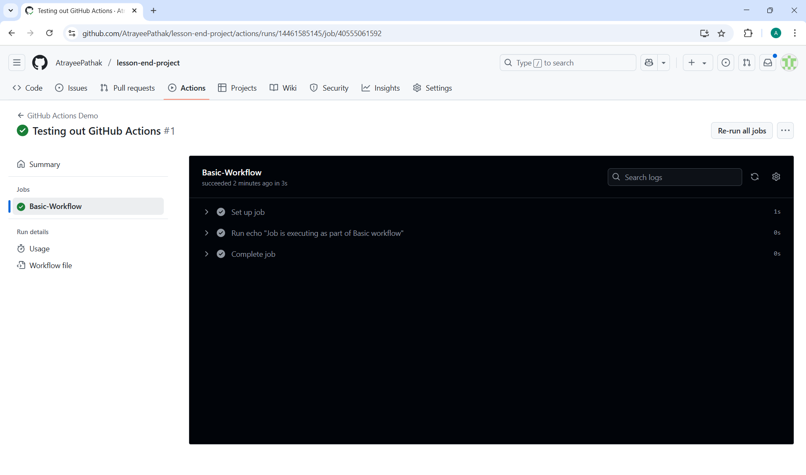

Calculator in java

